GOOD NATURE – a celebration of our planet, its beauty and its fragility and the essential part we all play in preserving it.

30 emerging and eminent artists were invited to make a new work in response to the theme. The work explores the themes of nature, our planet and the environment today.

16 September to 28 October 2017
Tuesday- Saturday 10am – 5pm
CANDIDA STEVENS GALLERY Chichester West Sussex PO19 1BA

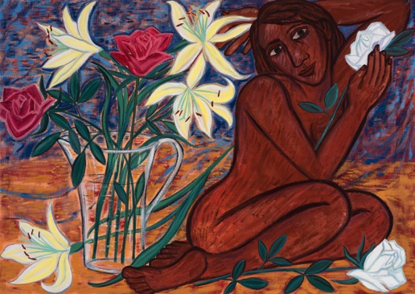
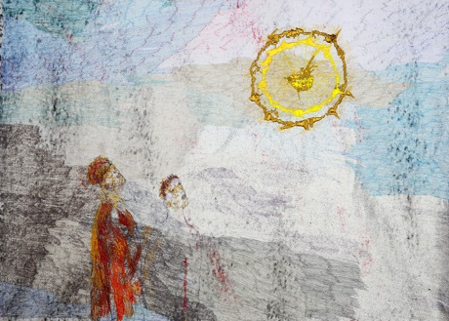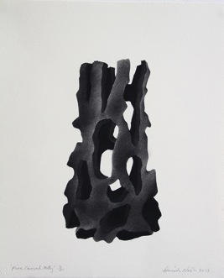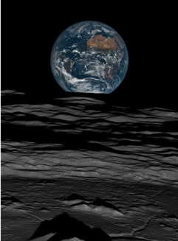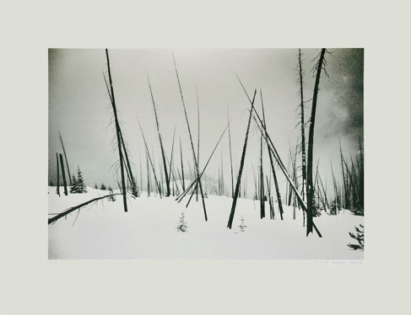
Top left and clockwise: Alice Kettle, David Nash RA OBE, Michael Benson, Eileen Cooper RA OBE, Nicola Green

GOOD NATURE celebrates the natural world through the observations of some of the leading artists working in the UK today who awaken our senses to the abundant beauty of our planet. They take inspiration from the warmth of the sun, the green lungs of the forests and the dark depths of the oceans, alongside all life that teems in and under them. We are reminded of the changing and fragile state of Earth and are invited to reflect on how it is necessary for all these elements to interconnect in order to exist.

Highly acclaimed, environmental sculptor David Nash RA OBE shows a work created from a Holly tree, charred in his distinctive style, with an associated print. Eileen Cooper RA OBE, and this year’s curator of the RA Summer Show, includes a painting inspired by the domestic use of nature. Stephen Farthing RA makes a new print about the escapism nature provides. Returning from highly successful exhibitions at Venice Biennale, Stephen Chambers RA takes a humorous look at manmade versus nature whilst Nicola Green makes a series of silkscreen prints in response to deforestation. It is a piece she says that she has always wanted to do but never had the right opportunity. Tom Hammick, responds with an atmospheric painting inspired by the power of what lies beneath the earths crust and the pioneering textile artist Alice Kettle makes a piece about the power of the sun. In contrast, Maciej Urbanek draws attention to the beauty found in the shade of the forest.

Wildlife observations include a new bronze of boxing hares, by award winning sculptor Hamish Mackie. The vulnerability of natural materials is addressed with an inverted marble sculpture from Almuth Tebbenhoff. Planetary landscape artist Michael Benson investigates new worlds with a look at Earth from the Moon. Science inspired sculptor Briony Marhsall explores new materials, directly from nature, with her compacted earth piece. In all, over 30 selected artists show an individual piece on this important and increasingly relevant theme for our time. Curator, Candida Stevens, comments:

"I have chosen to bring together these artists to concentrate our thoughts around the planet at a moment when its beauty and fragility are deeply affected by our treatment and explorations of it. I want to see how artists and thinkers will respond to this important theme. The show is curated to be a thoughtful and probing look at our place, and us in the natural environment. I hope too that it will create positive reactions from those who come to see the work and encourage them to make changes for the long term conservation of our world " Candida Stevens, Curator

The gallery has also invited natural world explorer, and author of Natural Navigation, Tristan Gooley to write an introduction to the exhibition and provide a talk. He knows from his years of experience giving talks that lecturing people on the environment is not the way to engage them, it is inspiring them that elicits enthusiasm to be proactive. In this spirit, GOOD NATURE aims to take inspiration from all that is good about nature and hopes to bring out the good in all our natures to positively play our part in its preservation.
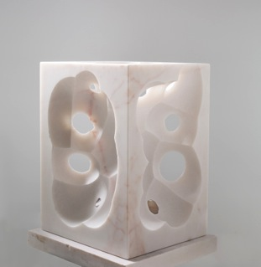
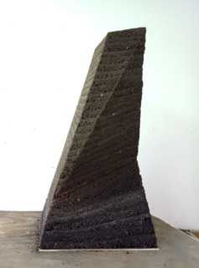
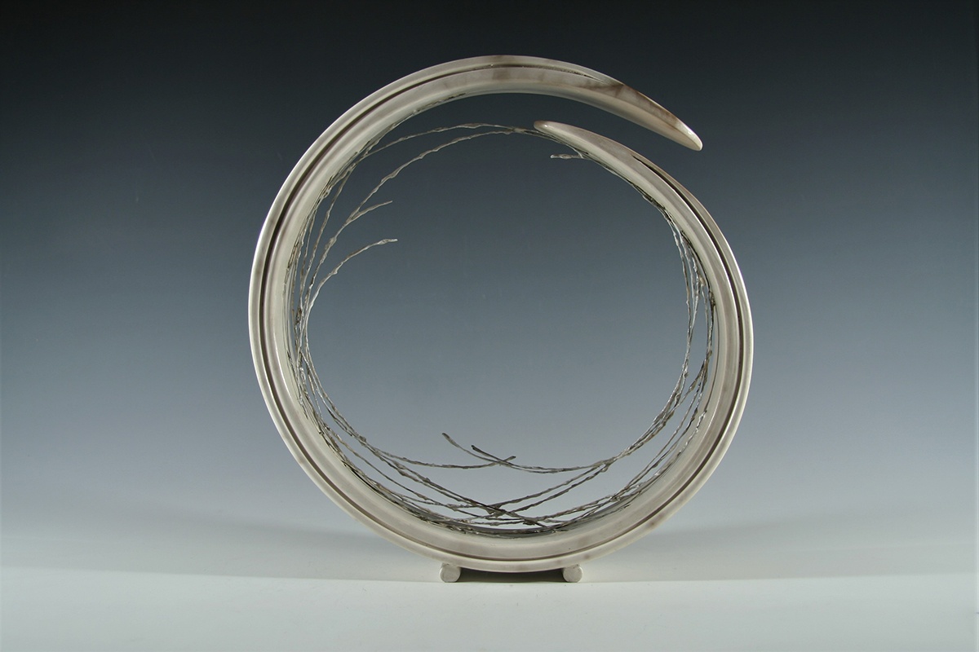

From left and clockwise: Antonia Salmon, Briony Marshall, Almuth Tebbenhoff

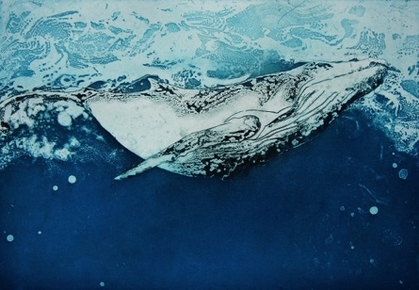
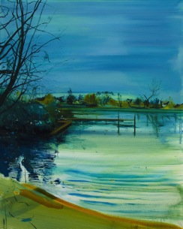
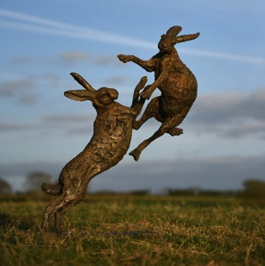

From left: Calum McClure, Marion MacPhee, Hamish Mackie

- ENDS -

NOTES TO EDITORS

LISTINGS INFORMATION:

TITLE: GOOD NATURE - a celebration of our natural world

EXHIBITION DATES: 16 September to 28 October 2017

ADDRESS: Candida Stevens Gallery, 12 Northgate, Chichester, West Sussex PO19 1BA

OPENING TIMES: Tuesday - Saturday, 10am-5pm

Web: www.candidastevens.com
Tel: 01243 528401
Mob: 07794 416569
Twitter & Instagram: @candida_stevens

PRESS PREVIEW – we would be delighted to welcome members of the press to preview the exhibition from 10am to 5pm on 15th September, or by arrangement.

ABOUT THE ARTISTS (named in release)

Michael Benson
Works at the intersection of art and science. Artist, writer, filmmaker, book-designer, and exhibitions producer, in the last ten years he has staged a series of increasingly large-scale shows of planetary landscape photography. Benson takes raw data from planetary science archives and processes it, creating large-format landscapes. He edits, composites, mosaics, and then finally optimizes these images, producing seamless photographs of landscapes currently beyond direct human experience. His latest work, Otherworlds: Visions of our Solar System, features an original new hour-long ambient composition by Brian Eno titled Deep Space. His work is shown internationally, including shows at the Natural History Museums in London and Vienna.

Eileen Cooper RA OBE
An important British artist, whose work is instantly recognizable and held in many public collections, notably the British Museum, Imperial College, the Arts Council Collection and the V&A. Elected a Royal Academician in 2001, in later became the first woman to be appointed 'keeper' of the Royal Academy of Arts. In 2017 she was curator of the RA Summer Show. A print maker and painter, her stylised work is rooted in a figurative tradition, characterized by the use of bold linearity and formal composition. Narratives abound, her protagonists are surrounded by imagery that often suggests tension, and the female form is always her starting point.

Stephen Chambers RA
Stephen Chambers studied at Winchester School of Art from 1978 to 1979 and then at St Martin's School of Art from 1979 to 1982. He graduated with a Masters from Chelsea School of Art in 1983 and elected to the Royal Academy in 2005. In 2016 he was awarded an honorary fellowship by Downing College, Cambridge. In 2017 he became the first British artist to hold an exhibition at the Palazzo Dondola as part of the 57th International Art Exhibition, Venice Biennale. His work concentrates on arrangements of flat patterns are placed in expertly pleasing arrays of geometry. The central subjects are haloed with bold, and extraordinarily uplifting colour combinations. Areas of the pictures are increasingly overlaid with carefully applied pattern taken from traditions of ornament in western and eastern art. Dots or spots like fireflies represent clusters of energy or nature’s imperfection. The stillness of the images makes the gestures of anxiety or tension slower to realise.

Nicola Green
Nicola Green graduated from Edinburgh College of Art, Scotland, in 1998 and quickly rose to prominence for her portraiture work, earning international acclaim for her keen ability to draw out the essence of her subject, whether observing an individual or exploring wider social and cultural issues. She seeks to reveal human stories by creating her finished work from extensive primary material to highlight social themes of identity, faith, power and leadership. She has exhibited widely in the UK including the National Portrait Gallery, London, the Dulwich Picture Gallery, London and the Walker Art Gallery in Liverpool. In 2017, she takes part in the 57th International Art Exhibition, Venice Beinnale as part of the Diaspora Pavilion.

Stephen Farthing RA
Stephen Farthing RA studied at St Martin’s School of Art from 1969 to 1973 before completing a Masters Degree in Painting at the Royal College of Art in 1976. While at the Royal College, Farthing was offered an Abbey Major Scholarship, an honour that took him to the British School in Rome for a year. On his return to London, Farthing held his first solo exhibition at the Royal College of Art Gallery. Then, in 1989, Farthing represented Britain at the Sao Paolo Biennale, which led to a flurry of further solo shows around the world in the ensuing years, as well appearances in group exhibitions. In the same year as the Sao Paolo Biennale, Farthing became Artist in Residence at the Hayward Gallery. He joined the ranks of our Royal Academicians in 1998 and in 2000 was made an Emeritus Fellow of St Edmund Hall, Oxford. Farthing has lectured extensively at several global art institutions.

Tom Hammick
Tom Hammick is a widely admired British painter, Senior Lecturer in Fine Art, Painting and Printmaking at the University of Brighton and Visiting Lecturer Fine Art University of Ulster and Nova Scotia College of Art and Design (NSCAD University). He has work in many major public and corporate collections including the British Museum (Collection of Prints and Drawings), Victoria and Albert Museum, Bibliotheque Nationale de France (Collection of Prints and Drawings), Deutsche Bank, Yale Centre for British Art, and The Library of Congress, Washington DC. He is moved by the minutiae in life and reflects on man's place in the world. His seductive landscapes forged from painted canvas or cut wood, reveal the 'otherworldliness' of life. They are metaphors for the human condition; reflecting states of mind, or expression about transience, fragility and awe.
Alice Kettle
Alice Kettle studied Fine Art at the University of Reading and then Textile Art at Goldsmiths’ College. Today she is a highly influential artist in her field and Professor in Textile Arts in MIRIAD Manchester School of Art at Manchester Metropolitan University. Her stitched works, many the size of huge figurative tapestries, exploit the textures and effects made possible through the harnessing of a mechanical process to intuitive and creative ends. In placing textiles at the centre, she has established a unique area of practice by her use of a craft medium, consistently and on an unparalleled scale. Her work is represented in various public collections such as the Crafts Council London, the Whitworth Art Gallery in Manchester, the Museo Internationale delle Arti Applicate Oggi, Turin, Italy. Commissions include the National Library of Australia, the Scottish High Court in Edinburgh, Gloucester and Winchester Cathedrals and the School of Music & Drama at Manchester University.

Hamish Mackie
Hamish Mackie attended Falmouth School of Art and studied design at Kingston University. Hamish began sculpting full time in 1996. In 2014, he won a major public art commission for the Berkeley Homes Goodman’s Fields development in the City and went on to win the Public Monuments and Sculptures Association’s Marsh Award for Excellence in Public Fountains. His style is unique; and aims to capture the inner core, strength, and grace of the subject. His sculptures are his own interpretation, and not a photographic representation of the subject. Through his close observation and his expressive manipulation of the materials, he is able to capture an instinctive moment of animal behaviour.
Briony Marshall
Briony Marshall first pursued a degree in Biochemistry at Oxford University before following her passion for art. Making the decision to move from laboratory to artist’s studio, Marshall’s science background has greatly influenced her artistic practice, and it is through this microscopic lens, and her rigorous research, that she explores the place of the human in the context of scientific doctrine. As she states herself she is also “… interested in how you combine good art and good science without compromising either”. Her sculptures are less an explanation and more an exploration of the implications of the science for our understanding of truth and meaning. Marshall and her work are held in high esteem by both the arts and science worlds. In 2015 she was awarded a FIRST@108 Public Art Award and in 2016 she has been selected as one of the 175 Faces of Chemistry by the Royal Chemistry Society to celebrate their 175th anniversary.
David Nash RA OBE
David Nash was born in Esher in 1945. He studied at Kingston College of Art 1964–64; Brighton College of Art 1964–67 and Chelsea School of Art 1969–70. On leaving Chelsea, Nash moved to Blaenau Ffestiniog in North Wales, purchasing a chapel to function as his studio and home. Nash currently lives and works in North Wales. Elected to the Royal Academy in 1999, he is widely recognised for his sculptures created from unseasoned wood, which inherently alter after his intervention. Charred columns are a repeating theme in much of his work, which he says, “Charring transforms the surface from a vegetable material to carbon. The sense of scale and time are strangely changed. The charred form feels compacted yet distanced in space.”He has had several high profile solo shows, is widely collected and his work is
Almuth Tebbenhoff
Almuth Tebbenhoff studied ceramics at the Sir John Cass School of Art from 1972 to 1975. In 1981, she established her Southfields studio in a former church hall to pursue sculpture, first working in in clay and wood, before studying a two-year course in metal fabrication at South Thames College, London. Her early pieces were monochrome, mostly grey, abstract explorations of space and volume through geometric devices. Since the early nineties, she has been moving towards a freer mode of expression, creating explosive forms in bright colours through a steady evolution of processes, investigating her current themes of light, space and the origins of matter.

Maciej Urbanek
Maciej Urbanek is a Graduate of Goldsmiths College and the Royal Academy of Arts.
Since graduating from the RA Schools, he has been exhibiting internationally and working independently as an artist and curator. In 2015 he organised a critically acclaimed series of exhibitions entitled 10 One-Night Stands. The same year he received a prestigious ACE Award for Work of Art in Religious Context for his installation HS in St Michael’s Church in Camden, London. In December 2016 Maciej opened gallery URBANEK in South Dulwich and is also Photography Tutor at the Royal Academy Schools.

Other participating artists (please contact for more information if required)

Thomas Allen
Jonathan Ashworth
Violet Astor
Emily Ball
Pippa Blake
Kate Boucher
Hen Coleman
Lawrence Dicks
Rebecca Fontaine-Wolf
Kristina Hagstrom
Marion MacPhee
Calum McClure
Antonia Salmon
Tai-Shan Shierenberg
Giorgia Siriaco
Olivia Stanton
Silvy Weatherall

ABOUT THE CURATOR
Candida Stevens studied History of Art at University College London and Business Psychology MSc at University of Westminster and Art Finance and Collection Management with TIAS Business School. After 20 years of immersion in the visual arts, curating collections and directing small businesses, Candida set up independently as Candida Stevens Gallery in 2015. Since that time she has quickly established a reputation as a gallery of note in the UK, both for her ambitious curatorial themes and ability to attract important contemporary British artists to create and respond with new and vital work. She has curated over xx shows with major exhibitions including GOOD FIGURES (2015), ICON (2016) and GOOD NATURE (2017).

Images

We have new portraits taken by photographer Dan Stevens of several GOOD NATURE artists: Hen Coleman, Eileen Cooper RA, Jeremy Houghton, Hamish Mackie, Olivia Stanton, Pippa Blake, Irene Lees and Alice Kettle.

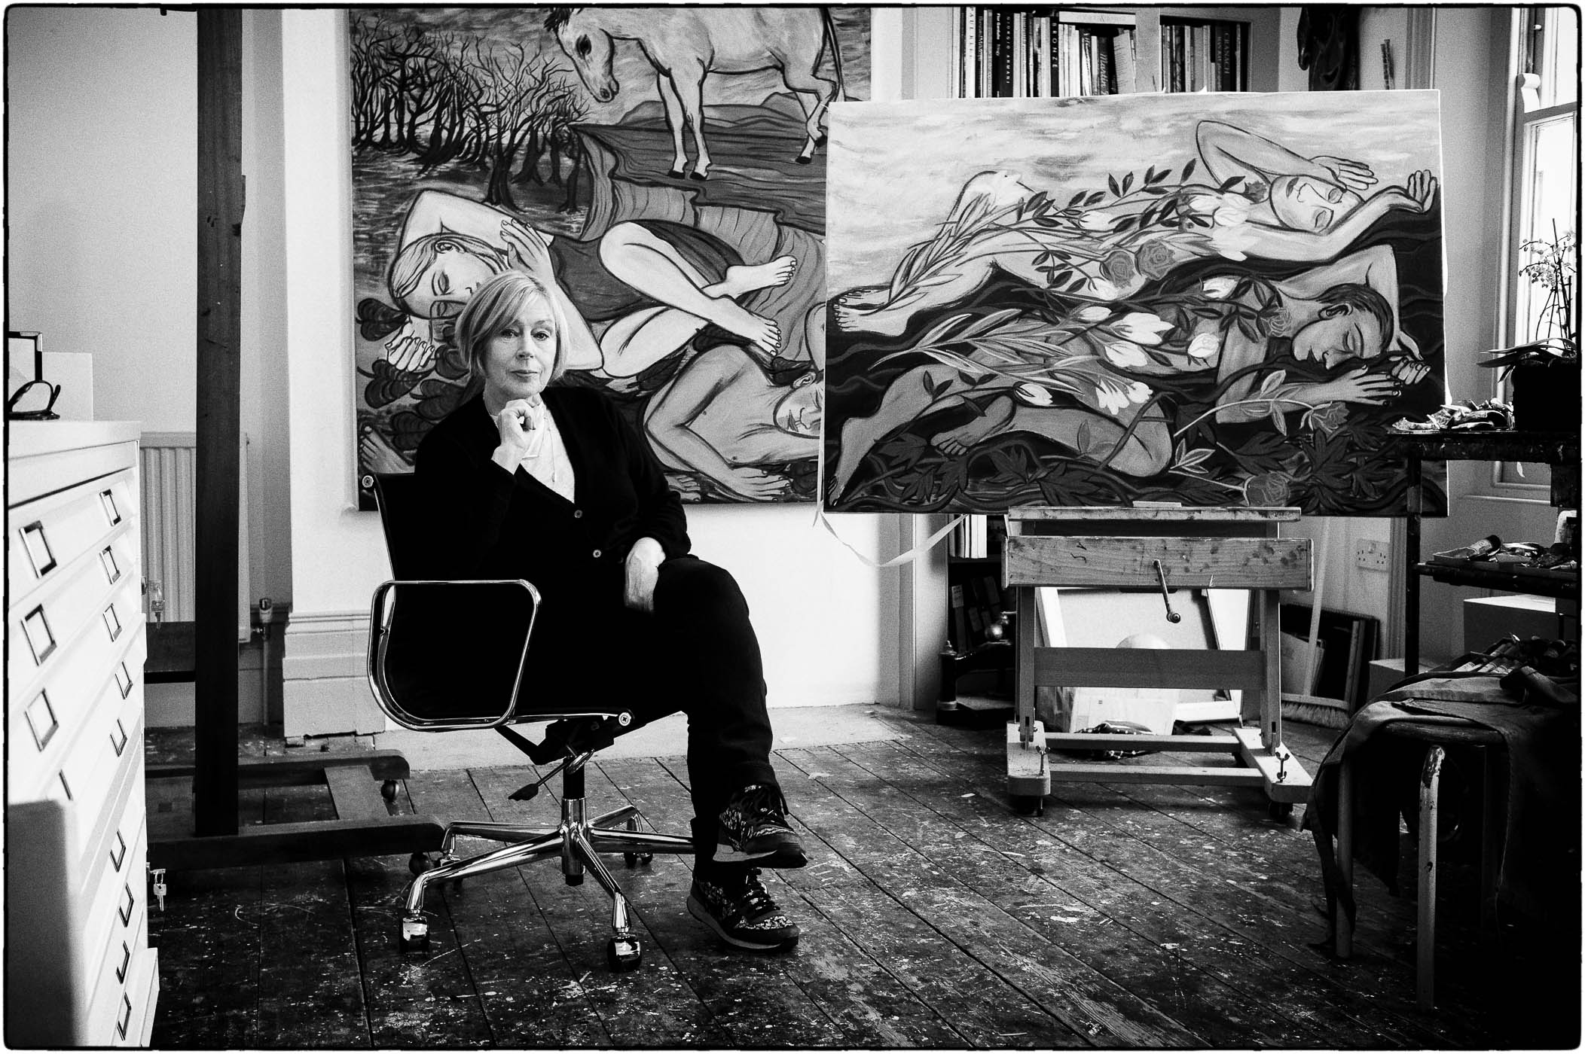
Eileen Cooper RA OBE by Dan Stevens

PRESS CONTACT:
Kerry Betsworth
kb@candidastevens.com
01243 528401/07990 800550

High Res images are available upon request.
Photographic credits: Dan Stevens (www.danstevens.com)

